📘 Assignment Module 5: Network Fundamentals and Building Networks

🔹 Section 1: Multiple Choice Questions
Q1. What is the primary function of a router in a computer network?
Answer: (C) Forwarding data packets between networks

Q2. What is the purpose of DHCP in a computer network?
Answer: (D) Dynamically assigning IP addresses to devices

Q3. Which device operates at Layer 2 and forwards data using MAC addresses?
Answer: (B) Switch

Q4. Which topology connects devices in a linear fashion using a backbone cable?
Answer: (B) Bus

🔹 Section 2: True or False
Q5. VLAN allows logical segmentation of a physical network
Answer: True

Q6. TCP is a connectionless protocol
Answer: False
- TCP is connection-oriented, not connectionless

Q7. Firewall monitors and controls network traffic
Answer: True

🔹 Section 3: Short Answer

Q8. Steps to Set Up a Wireless Network (SOHO Environment)
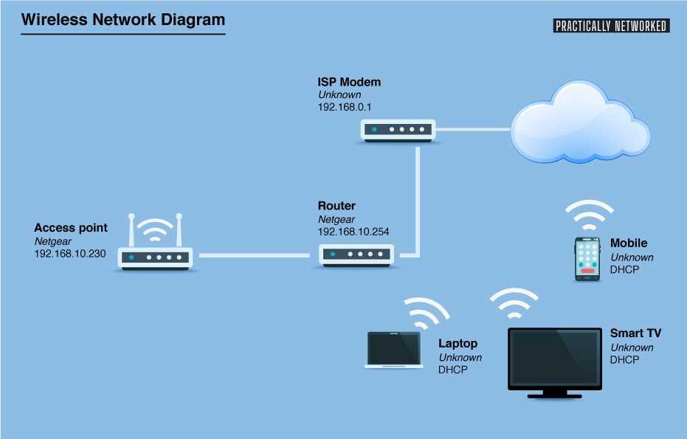
Answer:
- Connect modem to router using Ethernet cable
- Power on modem and router
- Connect a computer to the router (wired or wireless)
- Access router settings (e.g., 192.168.1.1)
- Configure SSID (network name)
- Set strong password and enable WPA2/WPA3 security
- Save settings and restart router
- Connect devices to the wireless network

Q9. Configure Router for Internet Access using DHCP
Answer:
- Login to router admin panel (via browser)
- Navigate to WAN/Internet settings
- Select connection type as DHCP (Automatic IP)
- Save settings
- Router automatically receives IP from ISP
- Enable DHCP server on router (LAN settings)
- Set IP range for clients (e.g., 192.168.1.100–192.168.1.200)
- Connect devices and verify IP assignment

🔹 Section 4: Essay

Q10. Importance of Network Documentation
Answer:
Network documentation is essential for efficient management and maintenance of a network. Without proper documentation, troubleshooting becomes slow, error-prone, and inefficient.
Importance:
- Helps in quick problem identification and resolution
- Reduces network downtime
- Ensures proper network management
- Improves security and accountability
- Assists new administrators in understanding the network
Examples of Documentation:
- Network topology diagrams
- IP address allocation details
- Device configurations
- Login credentials (securely stored)
- Firewall and security policies
- Hardware inventory
Conclusion:
Proper documentation ensures smooth operation, faster troubleshooting, and better scalability of the network.

